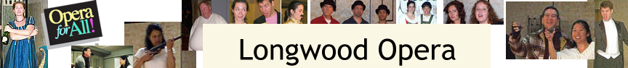

presents

An Evening of Gilbert & Sullivan

August 6, 2013 at 7:30pm

Christ Episcopal Church, 1132 Highland Avenue
Needham, MA

Admission at the door: Adults $8; Senior/Students/Children $6

Featuring James Hay, accompanist
and singers
Connell Benn, Katelyn Parker Bray, Marion Leeds Carroll,
Elaine Crane, Juliet Cunningham, Brian González,
Alyssa Koogler, Susan Craft Larson,
Kate Meifert, Ben Morse, Linda Nadeau,
Larry Seiler, Christopher Smith, and Jonathan Wright
in music from shows from HMS Pinafore to Utopia, Ltd!

Be sure to bring your voices - you're invited to join in Hail, Poetry at the end of the concert.

